New Jersey Institute of Technology

High School Provost

**Tracking the effect of temperature on the amplitude of a filament using Image Processing and Fourier Decomposition**

Anikait Singh

West Windsor-Plainsboro High School South

Dr. Gordon Thomas and Dr. Camelia Prodan

Arooj Aslam

Biophysics

NJIT

August 3rd, 2017

**Abstract:** This project involves observing the motion of microtubules that are stabilized with Taxol, a chemotherapy drug that prevents the polymerization and depolymerization of the microtubule. Prior to the experiment, the temperature of the microtubules was not fully controlled. Knowing the ideal temperature to run the experiment (where the microtubule is the most stable), enables us to determine the bounds at which the microtubule is most stable for running future experiments and even chemotherapy in the future. In order to determine the amplitude and frequency of the motion of the microtubule, we had to process the microtubule the microtubule with a filament tracking algorithm. This filament tracking algorithm relied on an ImageJ plugin called JFilament that skeletonized the microtubule and determined the position of the microtubule in each frame. From there, we filter the microtubule using a mean and a Gaussian filter in order to smooth the background of the microtubule and increase the contrast of the microtubule. This is followed by filament reconstruction that enables us to rotate portions of the microtubule in order to make it horizontal. This allows the algorithm to fit a Gaussian Intensity Profile to the intensities of the microtubule in order to attain subpixel resolution. Finally, a Fourier Transform is done with the shape of the microtubules to determine the amplitude of the microtubule in each frame. Comparing the mean amplitude and the variance in amplitude in each temperature allowed us to determine that there is too much noise in the image above 37ºC and not enough energy for motion below 20ºC. Thus the temperature during our further experiments needs to be controlled between these two temperature to attain the best accuracy in the tracking of the microtubule over time.

**Problem Statement:** This experiment involves understanding the effect that temperature has on the motion of the microtubules that are stabilized with Taxol.

**Significance:** The significance of this experiment is with Cancer. Microtubules are involved in the process of cell division: they constitute a large part of the mitotic spindle which separates the chromatids in the anaphase period of mitosis. With cancer, a cell undergoes abnormal cell division. Chemotherapy drugs such as Taxol hinder the abnormal cell growth by stabilizing the microtubules and preventing further cell division from occurring. However, cells develop resistance to these drugs. We believe that a microtubule moving at a resonant frequency causes the cell to develop resistance to the chemotherapy drugs. In this experiment, the temperature at which chemotherapy should be performed was determined.

**Specific Objectives:** In terms of experimentation, I started off with a control experiment: a string vibrating at a resonant/modal frequency. This string modeled a microtubule moving and our algorithm was able to determine the modes present in the vibrating string [i]. I moved forward to the temperature experiment and captured videos of microtubules at different temperatures and analyzed them through the filament tracking algorithm [ii]. In terms of algorithm changes, I added a nearest neighbor algorithm which allows us to track each point overtime in the algorithm (I was able to link the closest points to each other per frame). Finally, I added the functionality of the MIJ plugin for Matlab which enables the image processing aspect and the algorithm aspect to be connected.

**Setup:** For the vibrating string experiment, a String Vibrator, a pulley and mass was used [iii]. For the temperature experiment, slides were prepared with 50% hylite solution, 10μM of Taxol and 1000x diluted microtubules and placed on top of the stage of an inverted microscope. The microscope was focused at 100x magnification and the temperature was controlled with a heat lamp. The temperature of the stage was monitored with a multimeter with thermocouples. Fluorescent light was directed at the stage.

**Methods: String Experiment**: On a lab table, clamp down a string vibrator and pulley 1m apart. Connect a string to the string vibrator and a 100g mass. Determine the linear mass density of the string. Using the formula $f_{n}=\frac{n}{2l}\sqrt{\frac{F_{t}}{μ}}$, determine the frequencies of the first five modes of the string. Oscillate the string, at these frequencies and record videos of the string at these frequencies. Repeat for 0.5m string. Analyze string data through the filament tracking algorithm.

**Methods: Microtubule Temperature Experiment:**

**Sample preparation:** Clean slide with ethanol. Place BSA on glass slides and coverslips to prevent denaturing of protein and prevent it from sticking on the slide. With stuck down microtubules, add another protein called abadin. Prepare dilution of microtubules as follows. Use buffer GPEM Taxol (stabilize microtubule by preventing shrinking). Warm the buffer with your hand to prevent microtubule from breaking apart. Place .1μl solution of microtubule into 10μl (100x dilution). Drop 1μl of solution on slide. Put on coverslip on slide. Seal with wax using glass syringe. Label slide with temperature to test at. Use immersion oil on slide to prevent diffraction. Place the slide of the microtubule in the microtubule and bring it in focus on a microtubule that is stuck down on one end. Record video of the microtubule at Room temperature. Raise temperature of slide by 2ºC and record video. If signs of bleaching appear replace the slide with a fresh slide. Repeat recordings until temperature reaches 40ºC. Finally, place an ice covering on top of the slide. Measure temperature of slide and record video of microtubule.

**Image Processing (JFilament Plugin):** Import video as a tiff stack. Smooth the image to blur the background of the image. Open the JFilament plugin for the video. Draw the original “snake” (an approximation of where the filament is in the image) for the first frame. Set the parameters for the JFilament plugin as follows: Alpha = 15, Beta = 10, Gamma = 400, Weight = 0.5, Stretch Force = 100, Deform Iterations = 1000, Point Spacing = 2, Image Smoothing = 1.01. Deform the first snake. Then track all frames. If an error appears stating that the snake is too long, increase the value of gamma.

**Filament Tracking Algorithm:** Import data from JFilament skeletonization as a matrix of points. Import original video of the microtubules as a tiff stack. Initialize Parameters of the number of pictures to process using user input. The algorithm runs as follows. The initial matrix is padded with zeroes to ensure that each frame has the same number of points. Filtration then occurs in the code with the specified diameter for the mean filter and the standard deviation for the Gaussian filter. The final filtered image is the subtraction of the mean filtered image from the Gaussian filtered image. This filtration is followed by Filament Reconstruction Algorithm. The filament reconstruction occurs as follows. A spline fit is done on the points from the skeletonization. The spline is differentiated to determine the tangent line to the curve of the microtubules. From this, the angle of rotation can be determined to make a segment of the microtubule horizontal. Using this horizontal segment a Gaussian intensity plot profile could be plotted in order to determine the position of the microtubule in subpixel resolution. Finally, a Fourier transform is performed on the microtubule. This enables us to determine the mode amplitude of the microtubule’s movement.

**Methods Graphing the results:** Origin pro is used to graph the data from both the string experiment and the temperature experiment. In both experiments the mean amplitude vs mode number, the variance in amplitude vs mode number, and the mode amplitude over time (for the first 8 modes) was plotted. This was done with the data from the Matlab algorithm. [i] [ii]

**Results String Experiment:** The string experiment was a control experiment that demonstrated that the filament tracking algorithm was successful in determining the position of a filament to subpixel and accuracy. It also showed that the Fourier decomposition aspect of the algorithm could successfully determine the modes that were present in the vibrating string. This is shown in the clean peak in the variance for the string vibrating in the second mode [i] [iii] and the near zero variance in the other modes. We also determined the importance of frame rate in this experiment in recording the videos, which we took into account when recording the microtubules in the temperature experiment.

**Results Temperature Experiment:** The temperature experiment revealed that above 37ºC there was a great deal of noise in the data of the microtubule. This noise prevents accurate measurement of the amplitude of the microtubule as there was too much energy in the system and the microtubule was excited by the Brownian motion in a way that was abnormal. Temperatures that were too low (i.e. below 20ºC) did not excite the microtubule with enough energy and the amplitudes of the later modes were too small to be accurately measured. Thus the ideal temperature is between these two ranges and normal body temperature is within that ideal range.

**Conclusion:** This experiment confirms that the algorithm from the Brangwynne paper[1] is successful in determining the position of the microtubule and other filaments such as actin. We determined that frame rate was important in capturing videos of the microtubules and that higher modes need higher frame rates in order to have accurate measurements. We also determined the bounds for temperature on the stabilizing nature of Taxol for Microtubules.

**Future Work:** A step forward from this experiment would be to Determine the bounds for temperature on the stabilizing nature of other chemotherapy drugs for Microtubules and Microtubules without stabilizing agents (to prevent chemotherapy from affecting noncancerous microtubules). We would also like to move forward and look at the effect of temperature on the cancerous microtubules.

**Acknowledgements**

* New Jersey Institute of Technology Provost Program
* Dr. Gordon Thomas and Dr. Camelia Prodan
* Arooj Aslam
* Ms. Angela Retino
* NJIT High School Provost
* The Keck Foundation

**References**

1. Brangwynne, Clifford P., et al. “Bending Dynamics of Fluctuating Biopolymers Probed by Automated High-Resolution Filament Tracking.” *Biophysical Journal*, vol. 93, no. 1, 2007, pp. 346–359.
2. Gittes, F. “Flexural Rigidity of Microtubules and Actin Filaments Measured from Thermal Fluctuations in Shape.” *The Journal of Cell Biology*, vol. 120, no. 4, 1993, pp. 923–934

**Appendix**

[i] Graphs of Mode amplitude over time and Variance vs Mode Number for the string experiment (2nd harmonic 0.5 meter string)

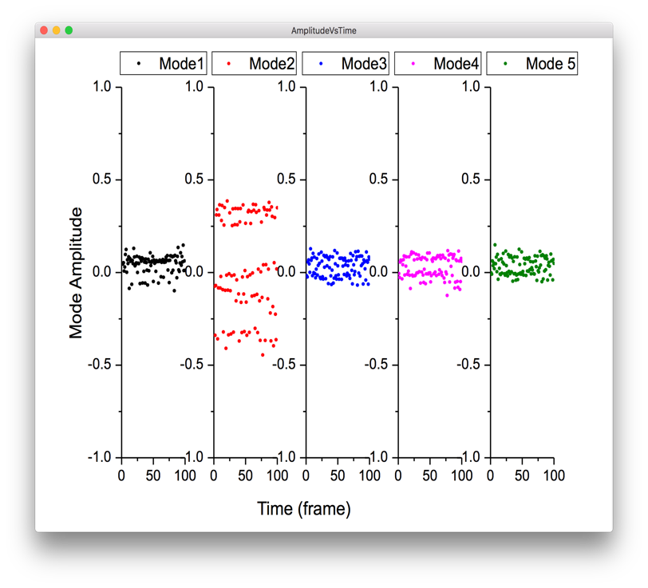

[ii] Data from the temperature experiment

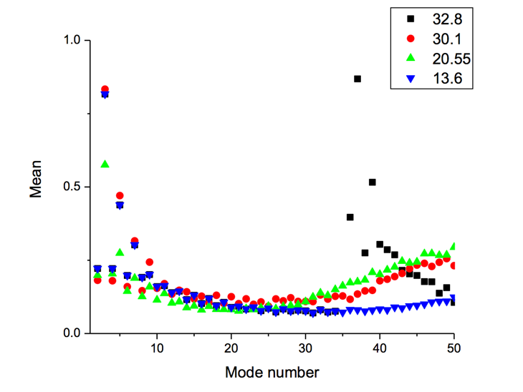 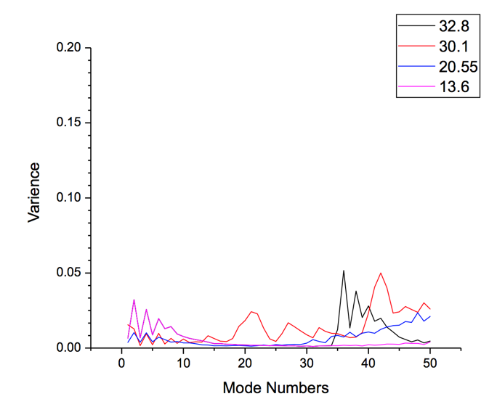

[iii] String experiment setup